Art History App-“Final Report-Proposed mobile app”

Buhum Luciana Florentina

II year

Programming on Mobile Devices

01.06.2021

Liviu-Octavian Mafteiu-Scai

**1.Abstract**

This report contains information regarding the development of the application chosen to be build in the Programming for Mobile Devices class. The details offered in this document are orientative, (as the app is in an early state of development) and are regarded to the motivation behind choosing the theme, the purpose of the app and the targeted users, the structure and the functionality of it, the development plan and the tools used in order of creating it.

**2.Goal and users**

The goal of the app is to educate the people(or freshen up their minds) in the matter of art history in an enjoyable manner and help them relaxing by (re)viewing a collection of some of the most famous paintings. The application targets individuals that have an interest towards art, also teachers or parents that would like to introduce children in this field using a more interactive way.

**3.Introduction**

The motivation that lies underneath this idea it was the fact that there aren’t many applications that involve learning about artists and their masterpieces and how their creations had a tremendous impact on the world and I think that in these times when technology is very present, it would be therapeutical to go back in time by visualizing and analyzing them. Another stimulating factor is that unfortunately less and less people show an interest towards the history of art, some of them showing ignorance to the point that they confused Leonardo da Vinci with Leonardo DiCaprio.

Briefly, this will be a learning app that will be divided by different levels of knowledge that will permit access to some levels. Every level will contain information regarding a movement in art(like period of time, description, particularities, painters and their paintings and their opposite currents in art) that will be followed by a quiz. Based on how well you did on a quiz, one can unlock some special levels where you receive fun facts about some painters or curiosities about the paintings.

To advance to a new level of knowledge, that will give the user a new title (like going from a total Novice to Apprentice or Connoisseur), he/she/they must pass a harder quiz that will test all that you’ve learned to that point.

**4.State of art**

As I said, there aren’t many apps of this kind, but the one that I found and is somehow close to what I have in mind is ArtChallenge, that just have a quiz with 150 questions about history of art, but it does not provide learning materials and is unstructured.

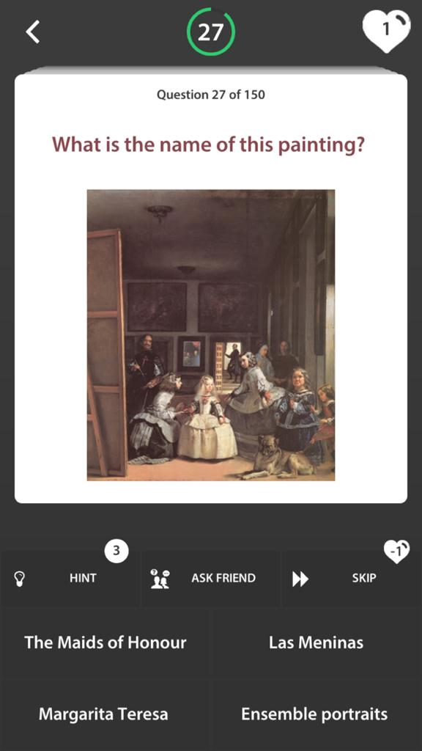

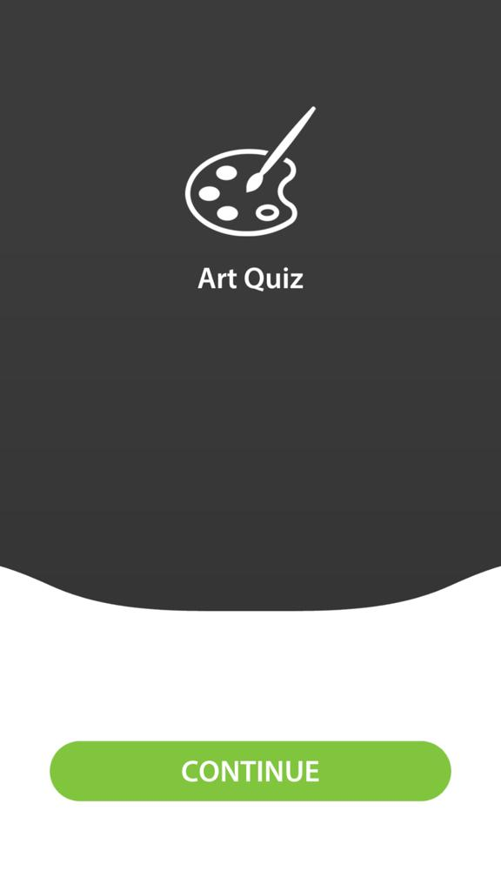

And perhaps Google Art, but more in terms of the purpose, theme.

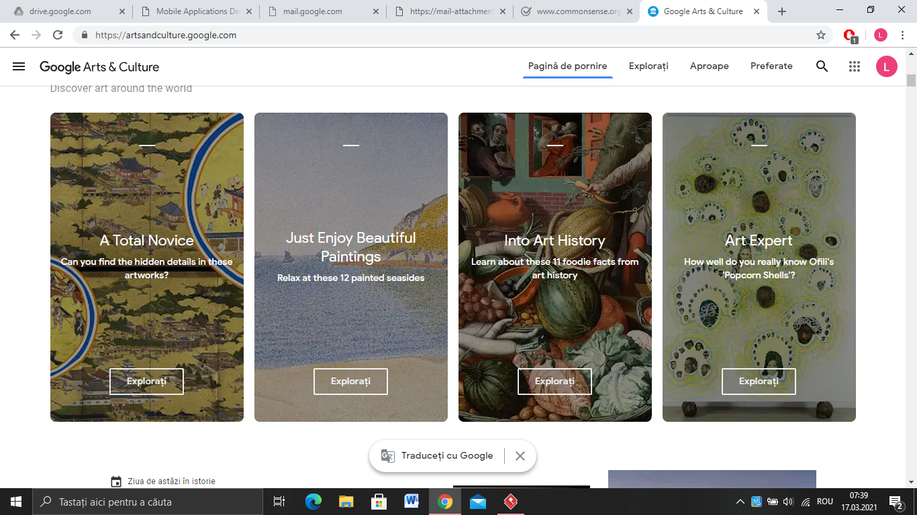

**5.What is the original contribution of the author**

The original contribution is that my app will be:

* more learning based, providing compressed information;
* the layout of the app, that will be divided in regions (first one giving you the title of: Novice)which will contain a few levels, each cointaing a quiz;
* the design of the questions;
* the fact that you will unlock some fun facts, curiosities about the artists based on your progress;

**6.Development plan**

**-** Development Enviorment: Android Studio

-Language: Kotlin

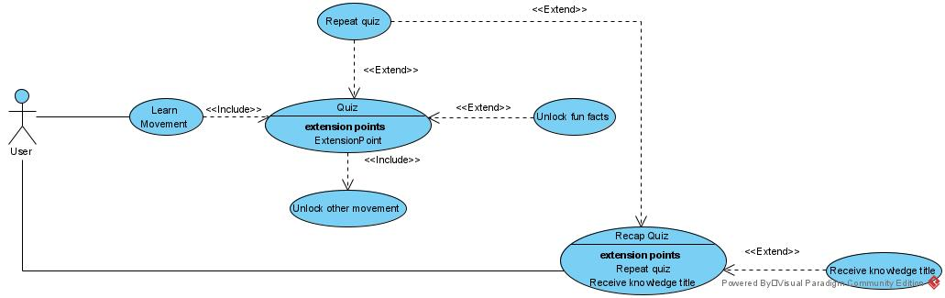

**7. User Manual**

The app starts with the app’s icon and a start button. By clicking on the START button, you will be sent to the next screen, where you can choose the category of the desired quiz by clicking on it. The next screen is the one containing the questions. The user should select an option and click on the submit button from the bottom. After de button is pressed it will uncover if the selected option was the correct one or not and the user needs to click on the Next Question button to move forward in the quiz.

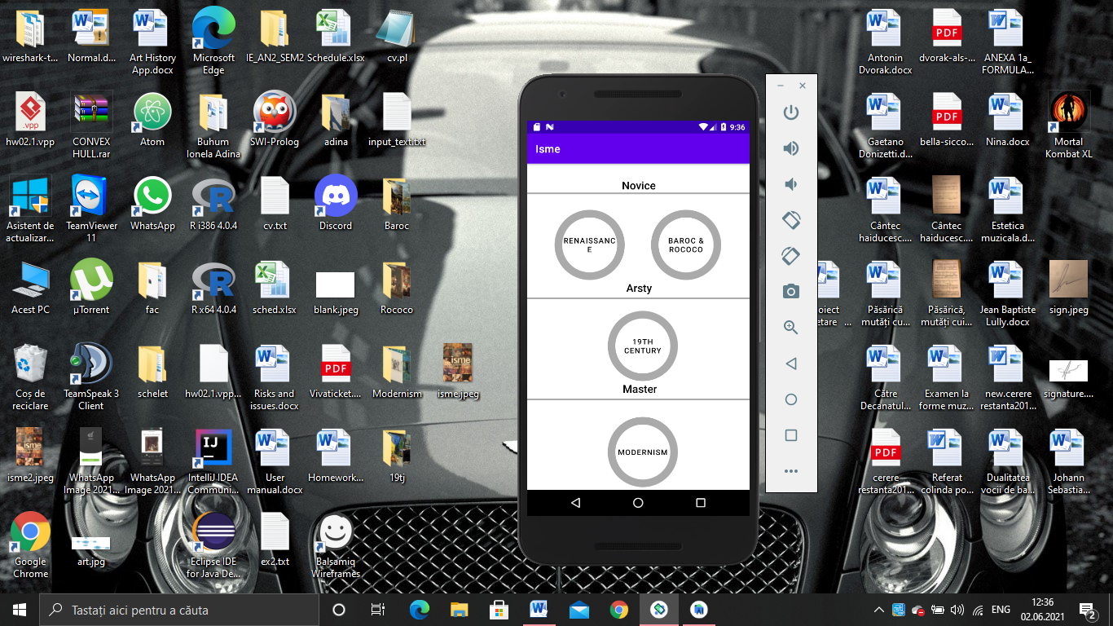

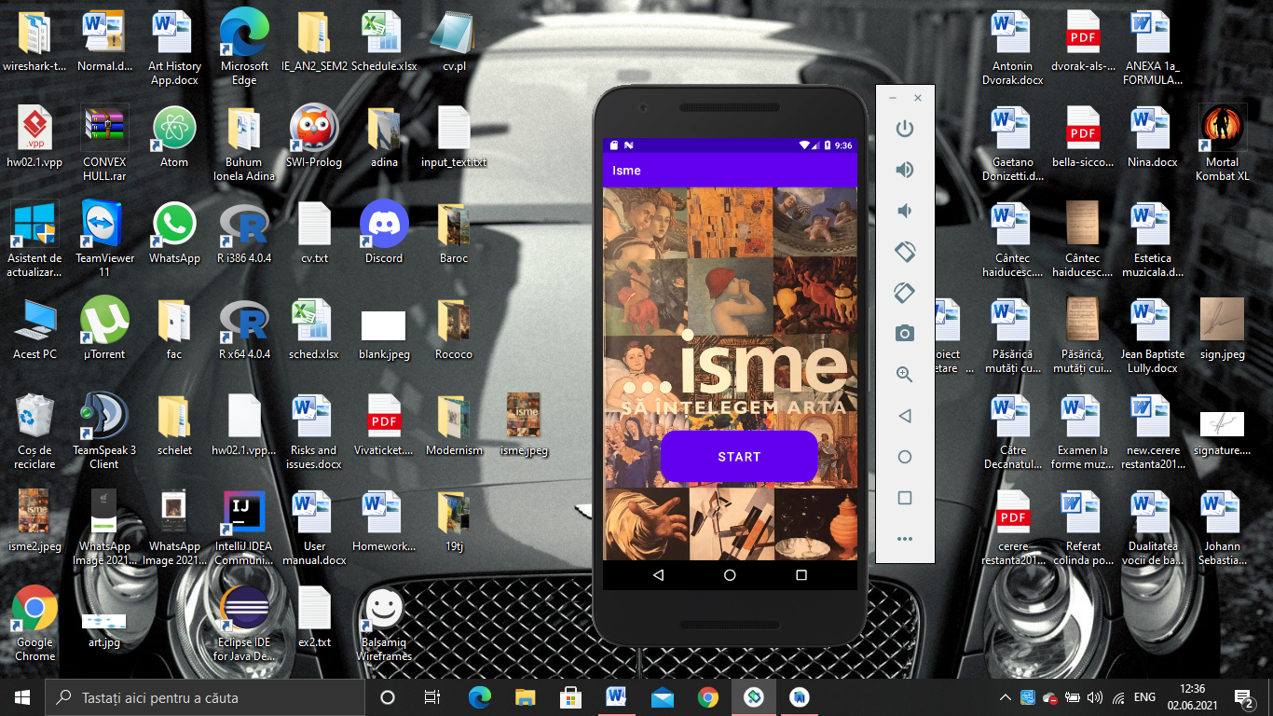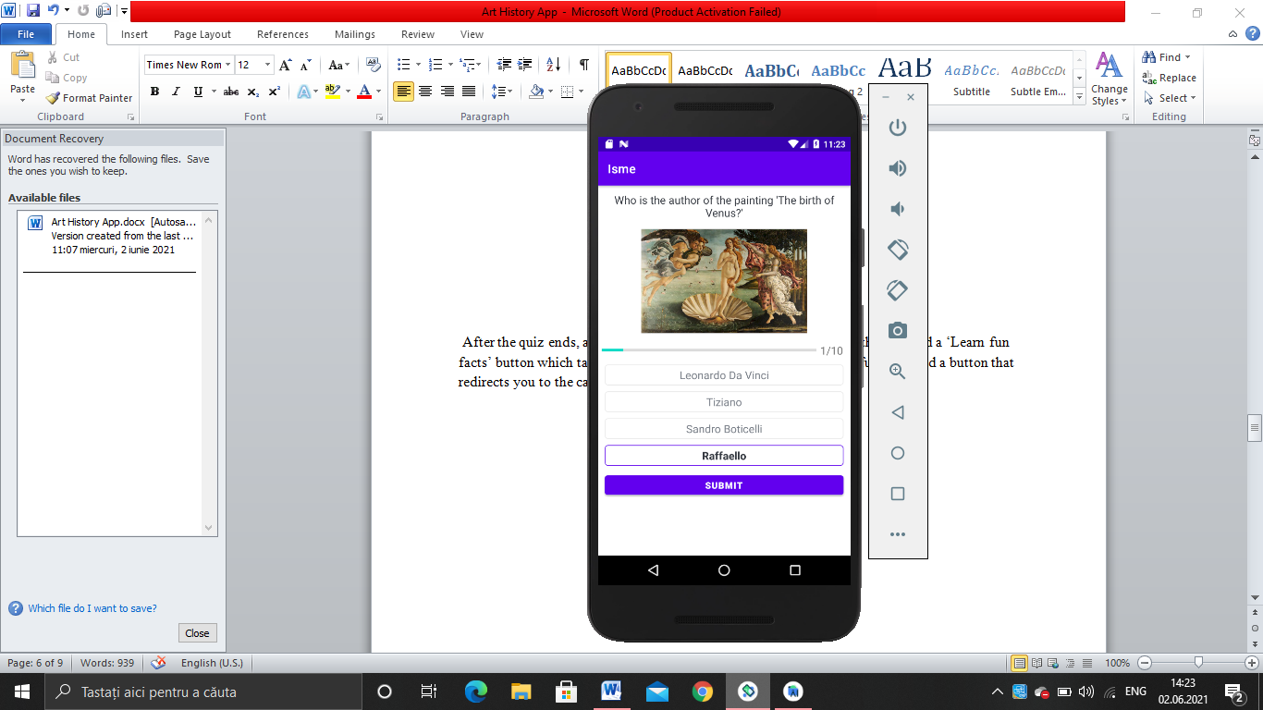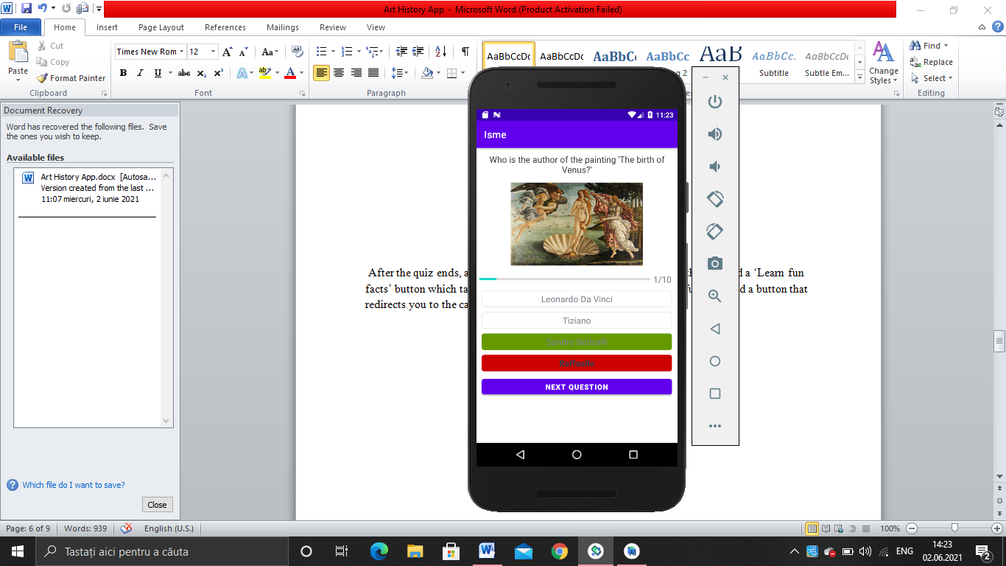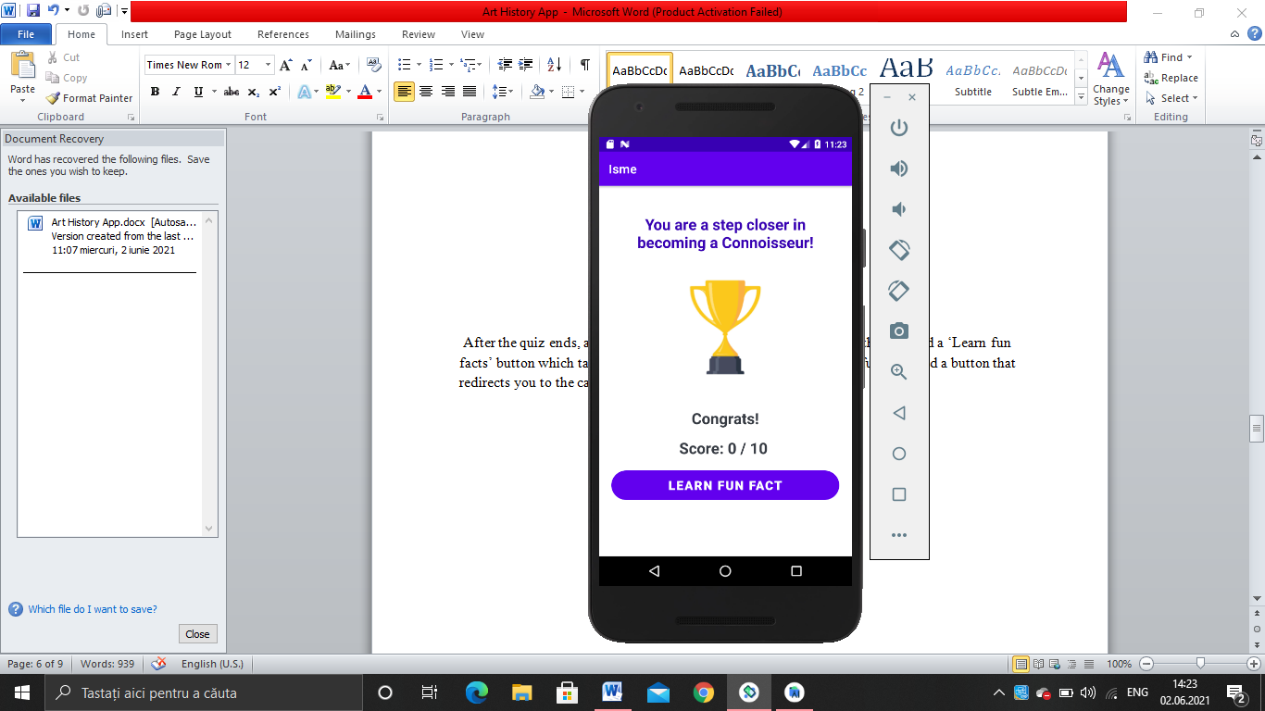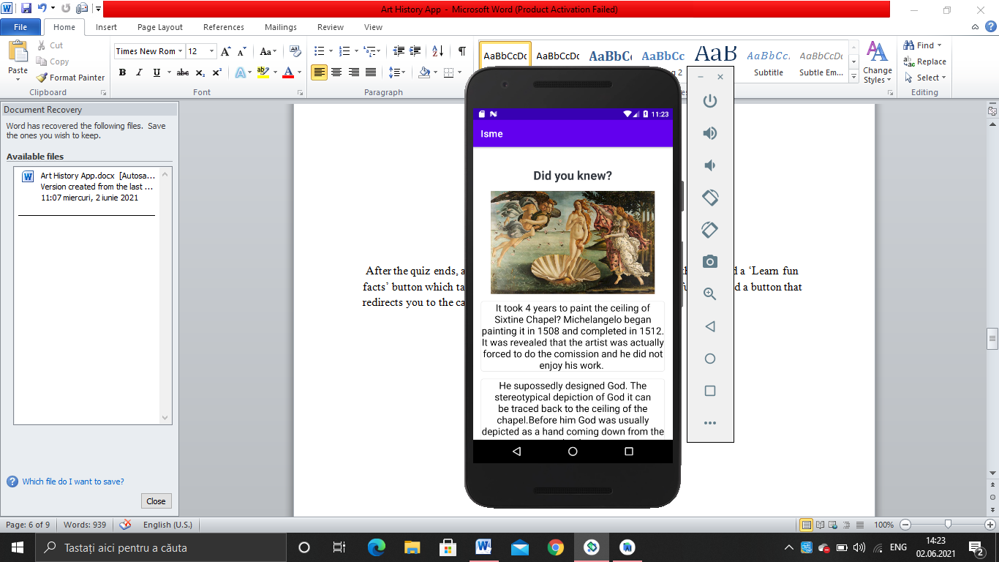

After the quiz ends, a result screen will be shown with the score of the user and a ‘Learn fun facts’ button which takes you to a screen from where you can learn fun facts and a button that redirects you to the category screen.

**7. App’s Structure**

**-**Informations such as the category which is selected, the nr of correct answers, current question index from the arraylist are stored in variables.

-the questions are objects of type Question with the attributes(id,image, option one, two, three,four,correctAnswer) and are stored in a file.

-function getQuestions: returns the arraylist of questions.

-function setQuestion: handles what the appearance of the question on the screen is, by setting the text of the textview and the image of the imageview to be the attributes of the objects of type Question.

-function onClick: verifies if an option is clicked and sets the UI for the selected option, then when the button ‘SUBMIT’ is clicked it verifies if the current question’s position == size of the array with the questions, if the user does not select an option, the system goes to the next question by incrementing the Currentposition variable and calling the setQuestion() function to set the new question. If the user selects an option, we also veirify if the current question’s position is equal to the ArrayList with the questions and if it is not we check if the selected option is equal with the correct answer and we call the function answerView() to set the selected option and the correct option appearances. If the current position of the question is equal to the array list of questions size, we create an intent and go to the next activity and with the intentputExtra() we pass the value of the correct answers and the number of questions.

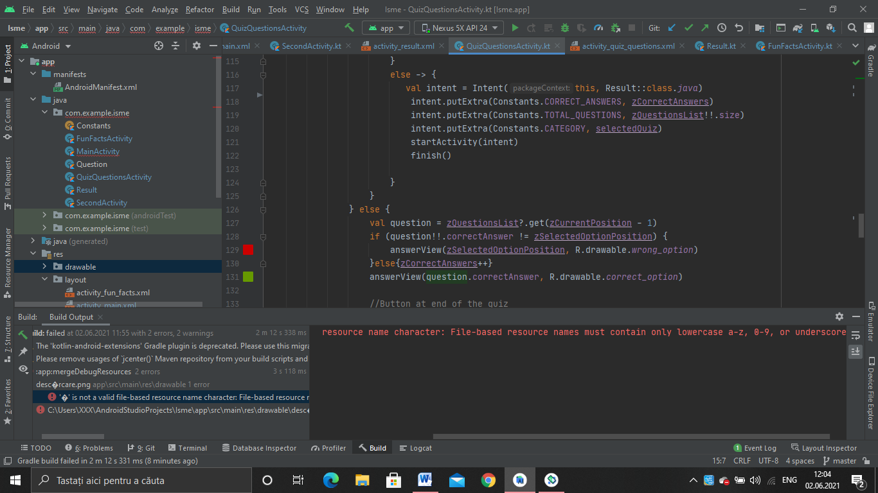

**8.References**

[**https://artsandculture.google.com/**](https://artsandculture.google.com/)

http://artchallenge.ru/